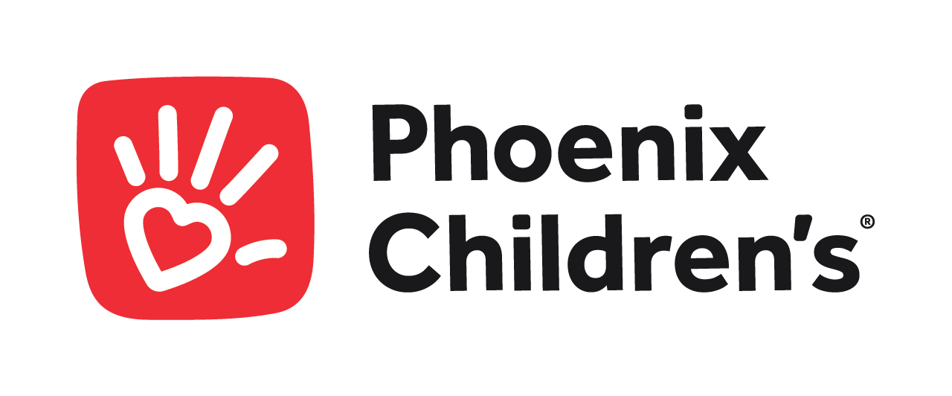
Pediatric Neuropathologist at Phoenix Children’s
Join Our Trailblazing Team and Shape the Future of Pediatric Medicine!
Phoenix Children’s is a beacon of hope, health, and healing in the heart of Phoenix. As a full-service, freestanding, tertiary medical center with 484 licensed beds and growing, we are on the brink of becoming one of the nation’s largest children’s hospitals. Our Division of Pathology and Laboratory Medicine is currently on the lookout for a board-certified Neuropathologist who shares our passion for making a difference in young lives.
Why Phoenix Children’s?
- Cutting-Edge Medicine: Thrive in an environment that is more than just a hospital; it’s a hub of innovation and medical breakthroughs.
- Active Pathology Service: Engage with over 200 neurological cases and nearly 500 specimens annually, ensuring your diagnostic skills remain unparalleled.
- Trailblazing Research: Be part of a team that invests $10 million annually in clinical research to push the boundaries of medical science.
- Teaching Excellence: Contribute to the future of pediatric medicine with our pediatric residency and fellowship programs.
- Phoenix Children’s Medical Group: Collaborate with over 800 dedicated physicians focused on enhancing the lives of children.
- Vibrant Community: Enjoy the dynamic lifestyle of Phoenix with its rich outdoor and indoor entertainment options.
Your Role:
- Diagnostic Expert: Delve into the intricate world of neuropathology, from brain tumors to muscle biopsies.
- Collaborative Consultant: Offer your expertise to clinical colleagues and researchers at the Barrow Neurological Institute and other affiliated institutions.
- Inspiring Educator: Mentor the next generation of medical professionals through our affiliations with the University of Arizona College of Medicine and Mayo Clinic Arizona.
- Flexible Opportunity: Customize your career path with options for full-time or part-time roles, focusing on pediatric neuropathology or expanding into adult neuropathology and surgical pathology.

Qualifications:
- Medical Degree (MD or DO) with board certification in Anatomic Pathology and Neuropathology.
- Completion of fellowship training in Neuropathology, preferably with a focus on pediatric neuropathology. Pediatric pathology fellowship is preferred but not required.
- State medical licensure and eligibility for medical staff privileges at hospitals or medical facilities.
- Strong diagnostic skills and the ability to interpret complex neuropathological findings in pediatric patients.
- Excellent communication and interpersonal skills for collaboration with multidisciplinary teams and effective patient care.
- Commitment to ongoing education, research, and professional development in pediatric pathology and neuropathology.
Ready to Make an Impact? If you’re eager to unravel the mysteries of the human brain and make critical diagnoses that change young lives, Phoenix Children’s offers the perfect platform for your expertise. We invite you to grow with us and leave a lasting legacy in pediatric healthcare.
Apply Now and become a vital part of our community that is dedicated to transforming the landscape of pediatric neuropathology.
About us:
As Arizona’s only Children’s Hospital, Phoenix Children’s is a 484-bed, freestanding specialty children’s hospital located in Phoenix, Arizona. The hospital serves a spectrum of patients ranging from local community general pediatric patients to complex patients from throughout Arizona and into surrounding states and northern Mexico. Out of the total number of beds includes 48 PICU, 48 CVICU and 49 NICU licensed beds.
We are a rapidly growing institution. Our healthcare system includes: the state’s only Level 1 Pediatric Trauma Center; a state-of-the-art motion analysis lab; a full-range of specialty services, including orthopedics, neurosciences, cardiovascular services, neonatology, and cancer and blood disorders; and a depth of high acuity specialties including heart, liver, kidney, bone marrow and stem cell transplantation, an active emergency department, and neonatal and pediatric intensive care units. Phoenix Children’s is a teaching hospital, leading the way for the next generation of pediatric providers through residency programs and fellowships, and is actively involved in clinical research, dedicating $10 million annually to support research activities.
Ready to make an impact? Apply now and be part of a team that’s rewriting the future of pediatric healthcare. Your expertise matters here!
For inquiries about the position, please contact:
David Blaha
Physician Talent Acquisition Partner
Phoenix Children’s Hospital
dblaha@phoenixchildrens.com

